Emails_Mar16-Mar19-2012

Yes, the man in the photo with the little girl and Mary Ashmore just jumps out at me as... that's Asa!
Happy hunting on your SLC trip. I will be very interested in what you find. - Don
----- Original Message -----
From: Teresa Smick
To: Don Duncan
Sent: Sunday, March 18, 2012 11:21 PM
Subject: RE: Census records

I agree, that if this "float" was in Weiser or Cambridge, it is unlikely that the little girl is Rilla Lenore as she died in Utah. I am still baffled on who she is. Who else would be in the photo with Mary Ashmore and Asa. It wouldn't be Mary, Asa's sister, the age difference is too much. We are sure this is Asa, right? I think so. Maybe I need to do more research on Mary Ashmore-Bratton-Duncan's whereabouts. Maybe McCadden was a partner in Colorado, then Utah and then went to Idaho, also. This might be something to put on my list of things to search for when I go to SLC. Maybe they have a business directory and I can see where Duncan and McCadden operated.
Thanks for all of your help and input.
Terri

From: don-duncan@comcast.net
To: tlsmick@hotmail.com
Subject: Re: Census records
Date: Sun, 18 Mar 2012 19:28:04 -0700
Terri,
Very interesting what can be found on the web these days.
Since Dad was born in Utah and then I believe they moved to Weiser for a few years (Circa 1905-12) before they moved to Cambridge it doesn't seem likely that the Willoughby in the Salubria Cemetary would have been connected with the family. Also, if the little girl in the 'Duncan - McCadden float' was Rilla Lenore then this likely puts this float in the Utah time period. I don't have any idea of the timelines for when and where Rilla Lenore was born and died or the families' move to Utah and then on to Idaho.

Only thing I feel fairly certain about from Dad's stories is that they lived in this house (not far from the West Side Grade School where Dad had the encounter with the music teacher when he was in 2nd grade) in the 1906-07 time period and beyond as per the 1910 census. (see attached picture of the Weiser house that is in my possession and a photo I took in 2008 of a house in the Weiser west side that could have been the same house before extensive remodeling)
If you have more information on timelines I would be interested in seeing what you have.
Don
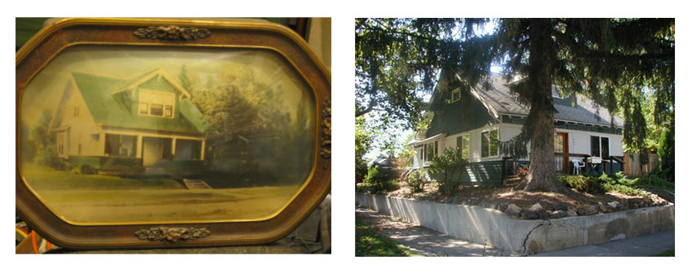

----- Original Message -----
From: Teresa Smick
To: Don Duncan
Sent: Saturday, March 17, 2012 10:08 PM
Subject: RE: Census records

Thinking about that McCadden guy in the Ducan and McCadden Blacksmiths, I keep getting the name Will in my head. I decided to investigate and found a Will McCadden buried in the Salubria cemetery. This is just north of Cambridge.

http://www.findagrave.com/cgi-bin/fg.cgi?page=gr&GSln=mccadden&GSbyrel=all&GSdyrel=all&GSob=n&GSsr=121&GRid=15592316&df=all&

He is about 22 years younger than Asa, but that doesn't mean much. Maybe that is why it was Duncan and McCadden. Anyway, if you have never looked at the find a grave site, it is kinda fun. You can actually view the headstones at the Cambridge cemetery. I replaced some of the stones for grandma Mildred's family, a couple of years ago. They had become unreadable. You can see them on the site, along with the Duncan family ones. My Jeffries relations are Weldon and Bertha Jeffries, William and Amanda Gulick, Nancy Jones, Baby Neese, and Gary and Michael Duncan. They have Asa's middle name wrong. It was Charles, thus the A.C. he always signed. I was told your dad provided the info, upon his death. He probably got the name from the child who died in Utah. (Patrick Asa) He probably heard that name and thought it was his dad's name.
There is also a James Milton Willoughby buried there. Could this be the man in the photo labeled J.M. Willoughby who might be your dad's namesake for the middle name? One can only wonder.
Teresa

From: don-duncan@comcast.net
To: tlsmick@hotmail.com
Subject: Re: Census records
Date: Sat, 17 Mar 2012 11:06:11 -0700
Thanks for the additional information about Asa and Rilla's two children that died. I think I had something about that stored way back in my memory but it would have been gone had it not been for your memory jog. I did know about the previous marriage to Elijah Bratton and the three boys. Both Mary Jane and Rilla must have been pretty tough women. Do you know how many children each of them had?
Don't recall ever hearing about Aunt Mary's middle name. A story Dad used to tell was that when she was a young girl she was very fleet of foot and could outrun all the boys. And probably along about the time she was preschool or first grade when she had to use the outhouse first thing in the morning she would get out of bed with nothing on and make a run to the outhouse bare naked. She thought she was so fast that no one could see her as she streaked to the outhouse and back.
I think it was mentioned that Dad's middle name came from an uncle or grandfather but I don't recall anything more than that. However, Willoughby makes a great clue for bank account verification etc now that they are getting away from just 'mother's maiden name'.
Dad had a very stylistic way of carving his initials on some of his tools and knives (the ones with the leather handles made of a tightly stacked ring of leather discs). See below.
I remember him telling about the time when he was staying with Asa in Joseph Oregon that he took off one morning to climb the highest mountain he could see from town and when he got to the top that he carved his initials in the rock. I have always planned on climbing that mountain and looking for Dad's initials carved in the summit block but so far I have never felt I had the time to do it when Justine and I have visited Joseph.
Incidentally, the old building on Joseph's main street that houses their city information office says that the building was originally a blacksmith shop. With more time in Joseph it wouldn't surprise me if one could dig up an old photograph from city archives that shows Grandpa standing in front of his blacksmith shop. I don't know how long Asa stayed in Joseph but I would be looking in approx. the 1916-1924 time period.
I attached my comments on the census records with a few other misc things I found a couple of years ago. I have no idea if the Asa Duncan from the 1830 Vermillion County census was part of our family tree.

Dad was more artistic than me... his carved initials were much more perfectly formed.
Incidentally, Dad was very proud that, although he was left handed, he could write cursively with his hand holding the pencil in a normal way rather than the way so many left handers sort of curl their hand and arm up over the top of what they are writing.

----- Original Message -----
From: Teresa Smick
To: Don Duncan
Sent: Saturday, March 17, 2012 8:43 AM
Subject: RE: Census records

I did not see your commentary. I do know one of the censuses shows Rilla as widowed. She probably thought Asa died somewhere if she had not seen him for a while. Or, perhaps, she knew that when he finally did show up that he was going to be dead! :) I think I told you, when you were here, that Mary Jane Ashmore Duncan was married before, to Elijah Bratton. Thus the 3 boys. I have photos of them. Also notice that your aunt Mary had the middle name of Ashmore. Did we ever talk about your dad's middle name? I have a photo of a J.M. Willoughby. I wonder if that is Jay's namesake? And is Willoughby a relation? Seems to be a chance since Mary had her grandmother maiden name for a middle.
Terri

From: don-duncan@comcast.net
To: tlsmick@hotmail.com
Subject: Census records
Date: Fri, 16 Mar 2012 22:37:05 -0700
Terri,
You may already have all these census records but I am also sending along a bit of my commentary on them.
Don

